

AHU CONTROLLER TEST DATA SHEET

P/N: AHU-R (63) 413-8005-2 Date: 03/04/2018 Time: 14:30

S/N: -1 Tested by: admin

Hardware Rev: BLDC_60A_V6 Approved by: admin

Software Rev: 5.3.8d

Tester Software Version: 1.2h

Equipments Used

Equipments Model No Serial No

Power Supply

Digital Multimeter

CAN Interface

Resistance Decade Box

PC

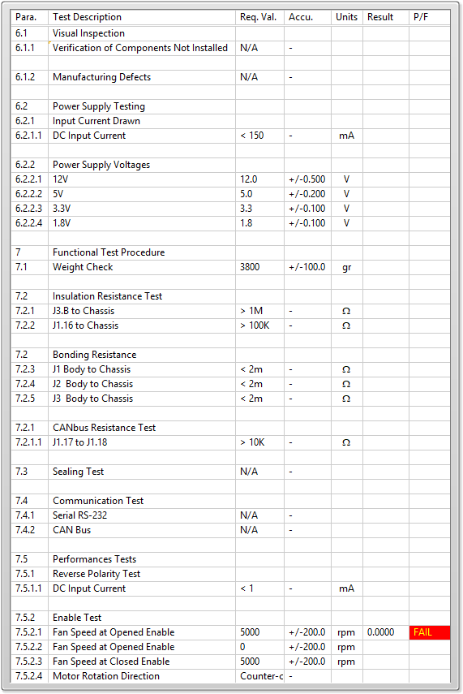

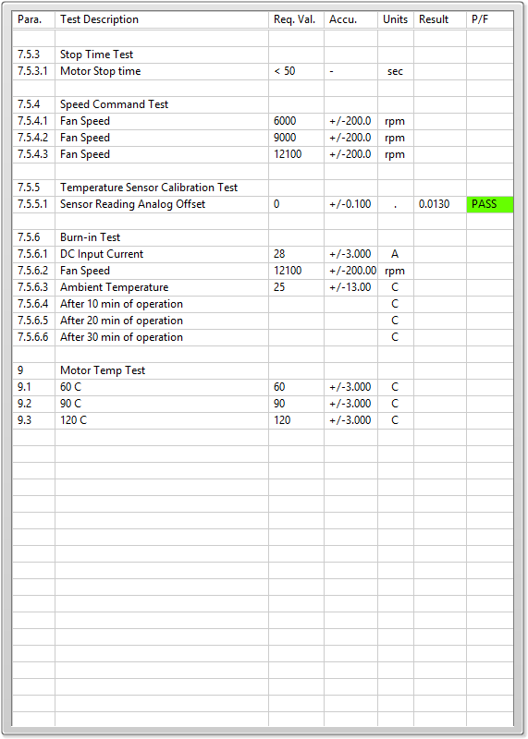

General result:

Test-Operator:____ admin_________ Q.A.:__________________________